**Isotopes**

**Isotopes** of an atom have the **___________________ number of protons** but a **___________________ number of neutrons**.

Therefore, isotopes of an atom have the **same ________________ number** but a **different _____________ number**.

The isotope is still **________________ charged** as there are still an equal amount of protons and ________________ in the atom.

An example of an element that has isotopes is ________________.

Nitrogen has many different isotopes, some examples are Nitrogen-14, Nitrogen-15 and Nitrogen-16.

As you can see in the diagram, the Nitrogen atoms all have ____ protons – this is what makes them Nitrogen atoms. However, each Nitrogen isotope has a different number of _______________.

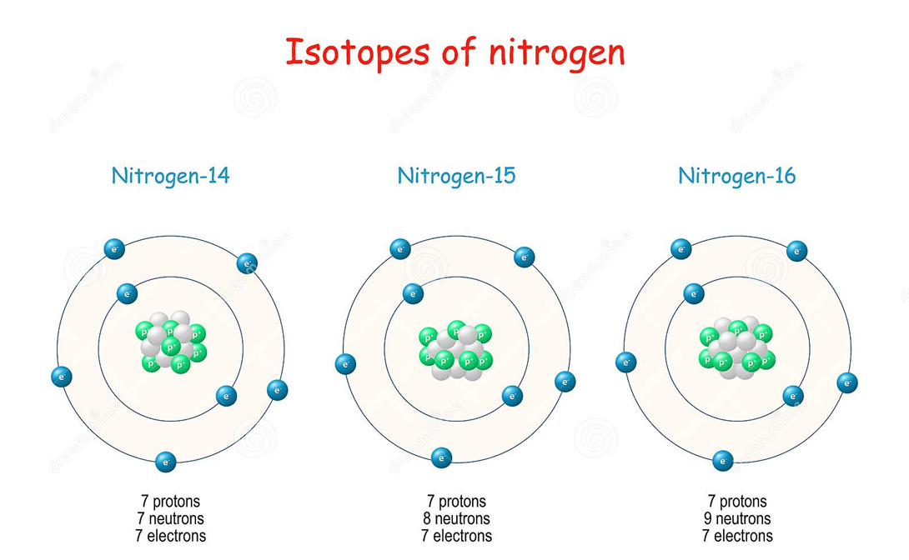

**Radioisotopes**

Most isotopes are **_____________**. Stable isotopes have a “happy” balance of protons and neutrons.

Some isotopes are not stable. An unstable isotope is called a **_________________ isotope or ___________________** because it emits radiation.

**_________________** is the release of energy in the form of waves or subatomic particles. Radiation is dangerous because it can harm the ___________ of living things.

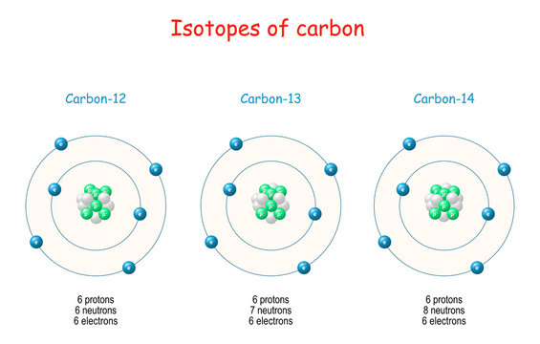Carbon has three _____________ occurring isotopes; Carbon-12, Carbon-13 and Carbon-14. All Carbon atoms have _______ protons; this is what makes them Carbon atoms. However, each has a different number of _____________.

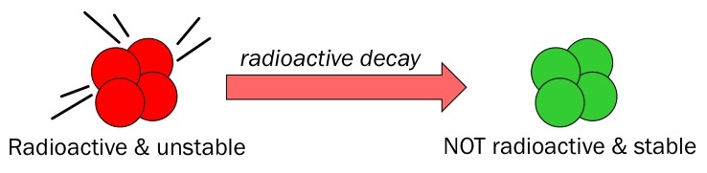Carbon-12 and Carbon-13 are stable, but Carbon-14 is ______________ and could decay at any moment. Generally, the _____________ the isotope (the more neutrons it has), the more unstable it will be. When isotopes ___________ they can either emit _______________ or _____________ in the form of ____________ radiation.

**How Much Do You Know?**

1. What is an isotope?
2. Why do isotopes have a different atomic mass?
3. Complete the table below for the Nitrogen isotopes.

|  |  |  |  |  |
| --- | --- | --- | --- | --- |
| **Isotope** | **Mass Number** | **Protons** | **Electrons** | **Neutrons** |
| Nitrogen-14 |  |  |  |  |
| Nitrogen-15 |  |  |  |  |
| Nitrogen-16 |  |  |  |  |

1. What is a **radioisotope**?
2. When a radioisotope undergoes nuclear decay, what can it emit?
3. Which isotope of Carbon is a radioisotope? Explain why it is a radioisotope.
4. Below are some isotopes of Oxygen. Complete the table for the Oxygen isotopes.

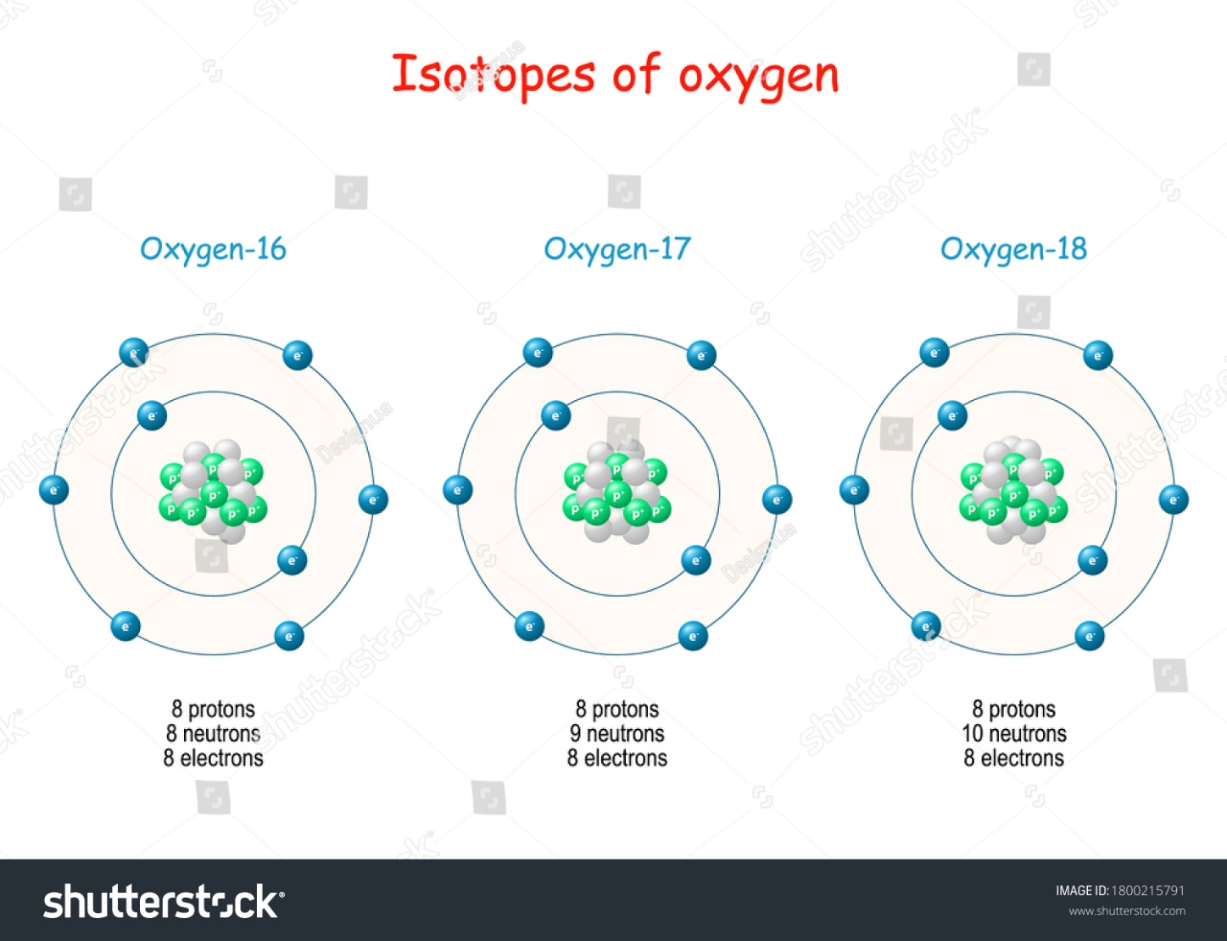

|  |  |  |  |  |
| --- | --- | --- | --- | --- |
| **Isotope** | **Mass Number** | **Protons** | **Electrons** | **Neutrons** |
| Oxygen-16 |  |  |  |  |
| Oxygen-17 |  |  |  |  |
| Oxygen-18 |  |  |  |  |

1. Which of the Oxygen isotopes are likely to be a radioisotope? Explain why.